**PRESS RELEASE**

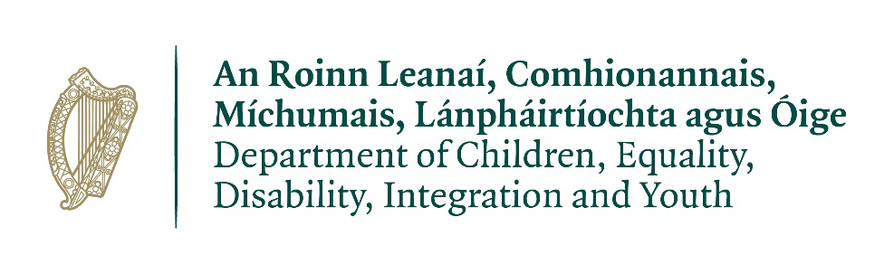

**Minister Foley urges childminders in County Kerryto avail of equipment grant**

**04 February 2025**

Norma Foley, Minister for Children, Equality, Disability, Integration and Youth is today calling on all childminders in County Kerryto avail of the 2025 Childminding Development Grant.

The Childminding Development Grant provides up to €1,000 to assist both registered and unregistered childminders who are providing a childminding service in their own homes.

In 2024, the grants Childminders inCounty Kerryreceived assisted them in enhancing the quality and safety in their service through the purchase of toys, childcare equipment, safety equipment, equipment to support inclusion and Science, Technology, Engineering, Arts, and Maths (STEAM) education. The grant was also used for the purchase of IT equipment to assist childminders to engage with training and registration processes.

The grant scheme is open to all childminders, including those who are planning to open a childminding business during 2025. 75% of the grant is paid in advance to help childminders with the upfront costs of purchasing equipment.

Making today’s announcement, Minister Foley said:

*“I am delighted to announce the launch of the 2025 Childminding Development Grant as one of the first actions in my term of office as Minister.*

*“Childminders play an essential part in the provision of childcare in all parts of the country, and I am fully committed to recognising and supporting their important role, and to following through on the National Action Plan for Childminding 2021-2028.*

*“I encourage childminders in County Kerry to avail of this funding opportunity, whether they are already registered or would like support in advance of registration over the next couple of years.*

*“The Childminding Development Grant provides funding for quality and safety equipment and can also be used to contribute to IT equipment.”*

The total budget of €500,000 reflects the high demand for the grant in previous years. It also reflects the Government’s commitment to support childminders to prepare for registration with Tusla. In line with the National Action Plan for Childminding 2021-2028, regulations written specifically for childminders came into effect for the first time in September 2024, making it possible for all childminders to register with Tusla and take part in the National Childcare Scheme (NCS).

Those childminders who were previously exempt from regulation have a three-year transition period until 2027 during which they are now able to register with Tusla but are not yet required to do so.

For further information about the Childminding Development Grant or the National Action Plan for Childminding 2021-2028, visit [www.gov.ie/childminding](http://www.gov.ie/childminding) or contact your local City or County Childcare Committee.

Aileen Kelleher from KerryCounty Childcare Committee, said:

“*The Department of Children, Equality, Disability, Integration and Youth’s Childminding Development Grant has been a huge benefit to many childminders in* *County Kerry.*

“*Any childminder with any questions about applying for the grant is welcome to contact us on* 066 718 1582.”

Applications for the 2025 Childminding Development Grant opened on Tuesday, 4 February and will close on Friday, 4 April.

ENDS