This Week in Childcare
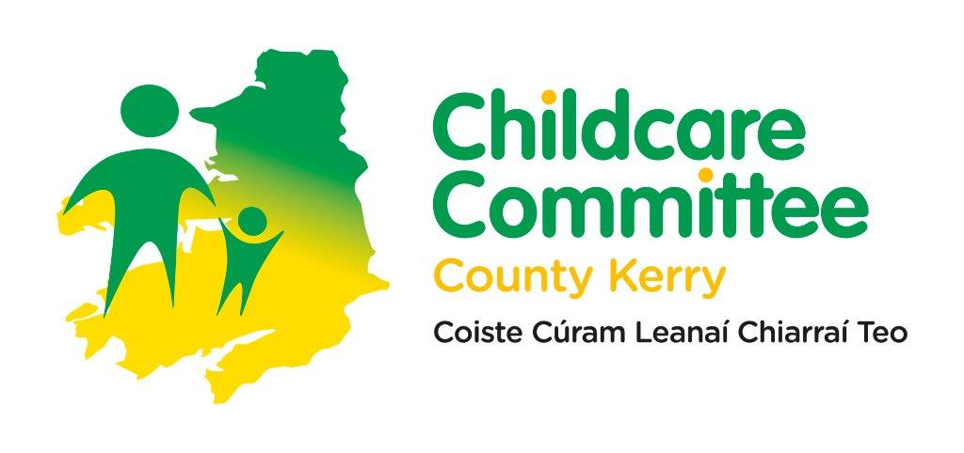

Weekly Bulletin
  - Issue 22: 2026 1st – 5th June 2026

Dear Colleagues

[Grab your reader’s attention with a great quote from the document or use this space to emphasize a key point. To place this text box anywhere on the page, just drag it.]
These are the announcements for the 1st – 5th June 2026

DEADLINES / IMPORTANT DATES
8th June 2026 National CPD mapping exercise
16th June 2026 Link Applications 2026/2027 closes
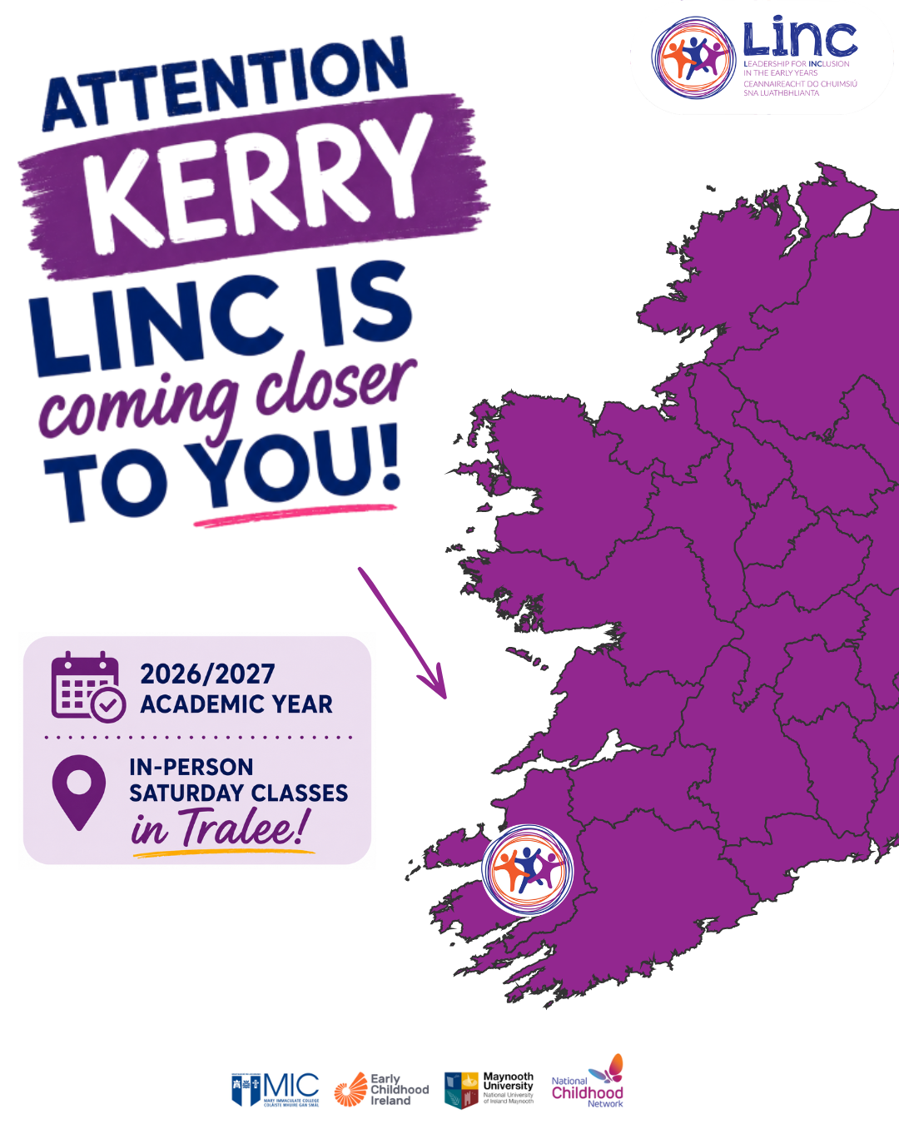
FOR YOUR INFORMATION
LINC Programme 2026/2027: Applications Reopening for a Limited Period
Due to significant interest in this year's LINC Programme, applications for the 2026/2027 academic year will reopen for a limited period from 10:00am on Monday, June 8 until 2:00pm on Tuesday, June 16, 2026. A limited number of places are available in the following in-person class locations:
• Cavan (Cavan Town)
• Galway (Tuam)
• Kerry (Tralee)
• Tipperary (Thurles)
• Wexford (Enniscorthy) Further information and application details are available here

Programme Readiness for ECCE, NCS, and CCSP Saver Programme 2026/2027 is now available

The first stage of Programme Readiness for ECCE, NCS and the CCSP Saver Programme 2026/2027 is now available for services to complete on the Early Years Hive.
Please note, Core Funding 2026/2027 will be available soon. Further details will be posted on the Early Years Hive. Please see Hive notification dated 04 June 2026 for further information.
Minister Foley announces details of maximum fee caps alongside over €480 million for Core Funding Year 5
On Wednesday 03 June 2026, Minister for Children, Disability, and Equality, Norma Foley announced the details of the new maximum fee caps for early learning and childcare services participating in Core Funding. The move will come into effect in September and will be accompanied by record State funding of €480 million this year for over 4,600 providers in the state’s Core Funding scheme. Core Funding supports providers to meet their staffing and general operating costs in return for maintaining a fee freeze for parents and, where applicable, observing maximum fee caps as well.
Further information on the Press Release can be accessed Here
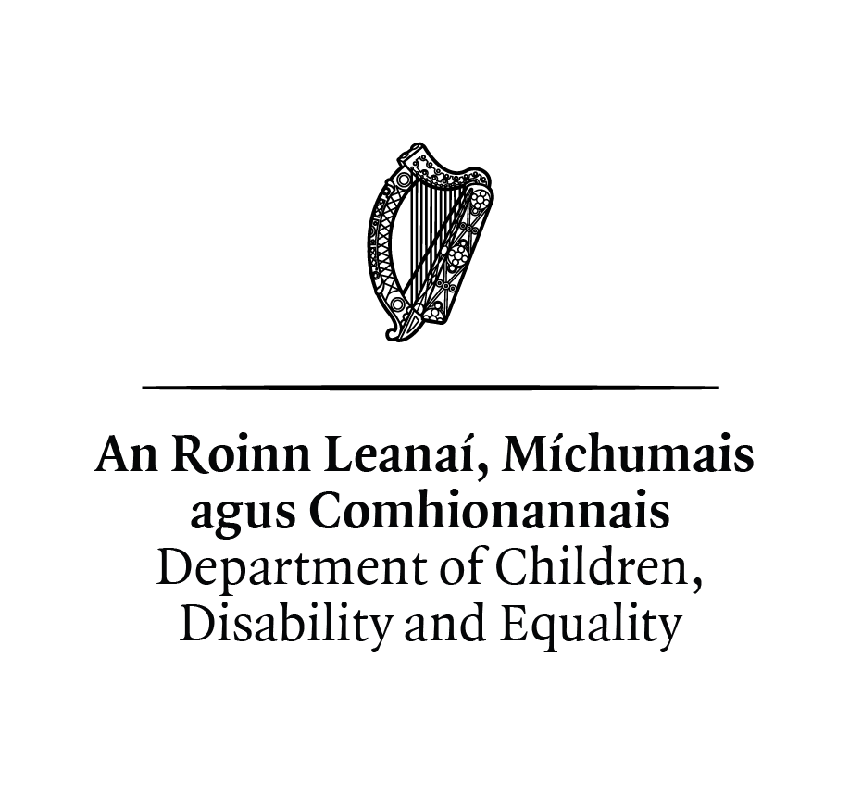
National CPD Mapping Exercise
National CPD Mapping Exercise *extended*
DCDE in partnership with Crowe Ireland, is undertaking a Mapping Exercise to identify existing CPD opportunities across the Early Learning and Care (ELC), School-Age Childcare (SAC) and Childminding sectors. The survey is open to everyone working in ELC, SAC & Childminding and can be accessed here: DCDE CPD Mapping Exercise - Educators Survey. The Irish language versions of the survey/ leagan Gaeilge de na suirbhé anseo are now available. Tionscadal Léarscála FGL RLMC – Suirbhé Soláthraí ; Tionscadal Léarscála FGL RLMC - Suirbhé Oideoirí The deadline for the survey has been extended until Monday 8 June.
State-led Early Learning and Childcare- Expression of Interest
The Department of Children, Disability and Equality is seeking a not-for-profit operator for the first project under the new programme of capital investment in State-led early learning and childcare. Applicants must be existing not-for-profit early learning and childcare services, registered with Tusla and the Charities Regulator, and participating in Core Funding.

Key dates for this process are as follows:
22 May 2026 | Indicate interest in and availability for attending the site visit
27 May 2026 | Submit any queries on the process
29 May 2026 | Site visit
4 June 2026 | Replies to queries will be issued
15 June 2026 (noon) | Deadline for applications

The application form and marking scheme can be accessed here, and the Application Selection Process here. The plans and other details can be found at the following links:
Boundary details
Ground floor and roof plans
Creche sections and elevations
Queries relating to this process should be directed to elcbuildings@dcde.gov.ie
Updated Aistear Workshop 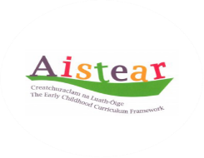
Kerry CCC are holding a workshop on the updated Aistear framework.
This information packed session will explore the updated language, concepts, principles, guidance for good practice and learning goals in Aistear the Early Childhood Curriculum Framework (2024).
This Session will take place in Kerry County Childcare offices on the following date: Tuesday 16th June 6.30pm – 9.00pm.
Bookings: rachel@kerrycountychildcare.com

Nurturing Skills Learner Fund Completing the Employment Record for Existing Students 2026 training sessions
For those who missed the training sessions, you can watch the recorded webinar and view the training slides via the links below. Additionally, the recorded webinar and slides from the sessions have been added to the Resources section of the Early Years Hive and NSLF Student Portal.
Please see links below:
- NSLF Completing the Employment Record for Existing Students Webinar
- NSLF Completing the Employment Record for Existing Students Training Slides

National Beep Beep Day 2026
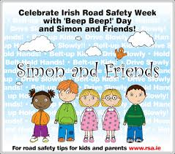
National Beep Beep Day 2026 will take place on Friday 9 October.
The ordering facility for the RSA Beep Beeps Packs, high visibility vests, Simon & Friends booklets and posters will open in early September through www.rsa.ie

Playful Parenting Webinar (for Infant Mental Health Awareness Week)
Playful Parenting with Dr Joanna Fortune, Psychotherapist, Author & Clinical Consultant
Monday 8 June @ 10 am. Please scan the QR code to register

Early Childhood Ireland research on children's access to EY and SAC
Early Childhood Ireland invites Early Years (EY) and School Age Care (SAC) service providers, managers, administrators, and educators/practitioners who are responsible for, or familiar with, admissions decisions in their settings to take part in a survey exploring admissions policies and practices in EY and SAC services. The survey will remain open until 10th June 2026 and can be accessed here

Kerry County Childcare Committee
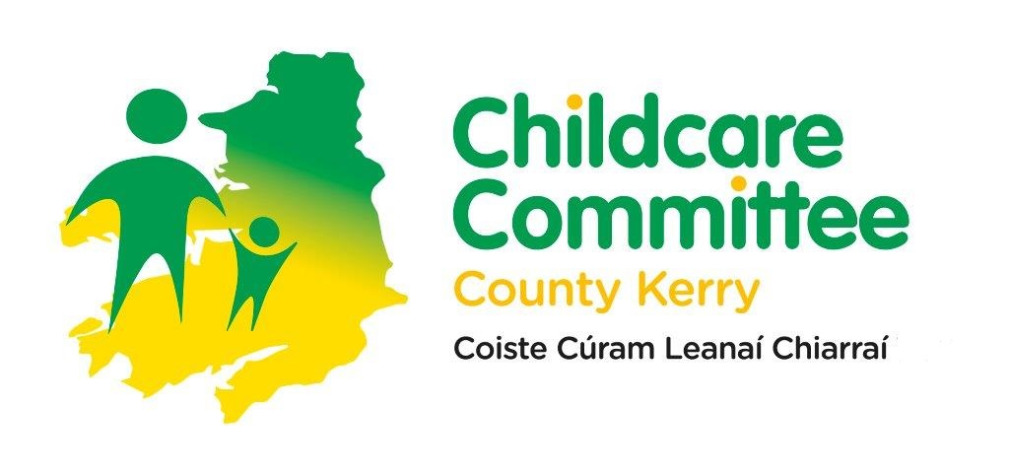
We invite you to follow our Instagram page here, visit our website here and like and follow our Facebook page for updates and relevant content.
Kind regards
Kerry County Childcare Committee

