This Week in Childcare
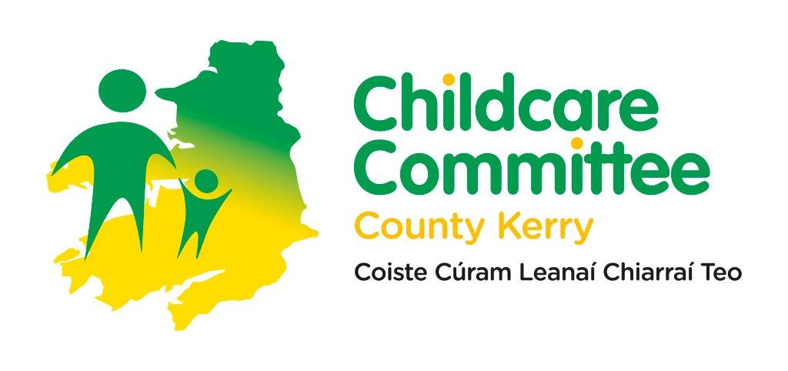

Weekly Bulletin
  - Issue 24: 2026 15th – 19th June 2026

Dear Colleagues

[Grab your reader’s attention with a great quote from the document or use this space to emphasize a key point. To place this text box anywhere on the page, just drag it.]
These are the announcements for the 15th – 19th June 2026

DEADLINES / IMPORTANT DATES
26th June 2026 Process for Continuing Students for NSLF closes

Programme Readiness for ECCE, NCS, and CCSP Saver Programme 2026/2027

Programme Readiness for ECCE, NCS and the CCSP Saver Programme 2026/2027 is now available for services to complete on the Early Years Hive.
For further support contact Pamela: pamela@kerrycountychildcare.com
Programme Readiness for Core Funding 2026/2027
Applications for the Core Funding 2026/2027 are now open. Partner Services contracted for Core Funding 2025/2026 that have completed the May Review and Confirm process and have an approved status can auto-populate their application using the information from the most recently approved 2025/26 Core Funding application. All retrospective Update Due Dates(s) for the 2025/2026 Core Funding programme year must be actioned before beginning the new application.
Following submission providers will have 21-days to accept the Core Funding Partner Service Funding Agreement 2026/2027. Additional resources are available under the Help and Support section on the EY Hive. You can access the Core Funding Year 5 (2026/2027) Funding Agreement here. The Overview of the changes to Core Funding Year 5 can be found here.

For further support contact Pamela: pamela@kerrycountychildcare.com

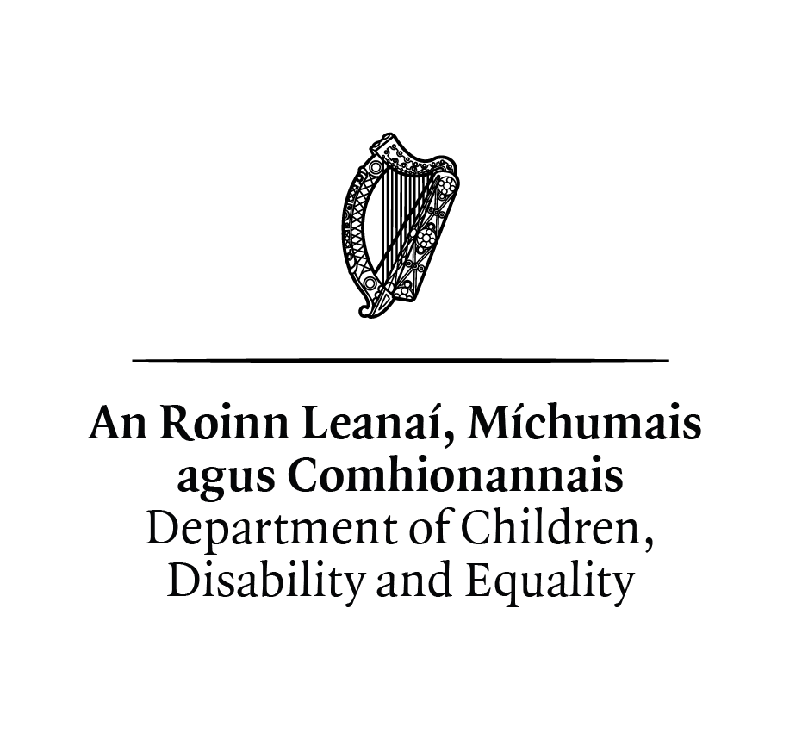
Building Blocks Extension Grant – Online Information Session
The DCDE have scheduled an online communication session for ELC services interested in making an application for funding under Phase 2 of the Building Blocks Extension programme.

The session is scheduled from 2.30pm to 4pm on Tuesday 23rd June (link below) and will include a short presentation to services on the programme including the application process. There will also be time at the end for a Q&A.

Building Blocks Extension Grant Phase 2 | Meeting-Join | Microsoft Teams

Nurturing Skills Learner Fund - Continuing Students 2026/27
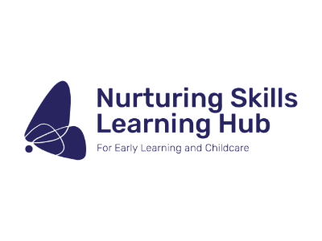
The process for Nurturing Skills Learner Fund (NSLF) Continuous Students to confirm their eligibility for the coming academic year 2026/2027 is now open and will close on 26 June 2026 at 5pm. Continuing students are existing students who successfully received NSLF funding for academic year 2024/2025 and/or 2025/2026 and are eligible to continue to receive funding for academic year 2026/2027.

It is the responsibility of the student to confirm their eligibility and failure to do so will result in NSLF funding being withdrawn. Once eligibility is confirmed, a new letter of Conditional Funding will be issued for the academic year 2026/2027. Resources from the recent training sessions held in May 2026 can be found in the resources section of the NSLF Student Portal and here.
AIM level 5 Transfer of Ownership
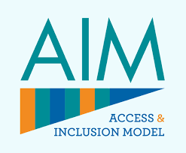
The Transfer of Ownership process for the 2025 programme call remains open. All services with AIM Level 5 equipment supporting children who are expected to complete their ECCE eligibility at the end of the 2025/2026 programme year are strongly encouraged to complete the transfer of ownership process as soon as possible. Equipment provided under AIM Level 5 must not be removed from the pre-school setting until the transfer of ownership process has been fully completed. Further information can be found here.
AIM level 7
As part of the AIM Level 7 redesign, the level of support allocated to a child is now determined following the submission of their AIM Level 4 application and the subsequent review of the child’s needs by Better Start. AIM Level 4 application should be submitted as early as possible for any child intending to access AIM Level 7 supports for the 2026/2027 programme call. Preliminary decisions on the level of support determined at the AIM Level 4 application stage will be issued from early July.
Where a child has an existing AIM Level 7 application under the 2025/2026 programme call and remains eligible for an additional year of support, no action is required at this time. Service providers are asked not to withdraw these applications in advance of the 2026/2027 programme call and can expect preliminary decisions to be issued from early July.
It is advised that AIM Level 7 Non-term applications for the current programme call are submitted as soon as possible.

Lets Get Ready 2026
Lets get ready has lots of useful information and animation videos for families on transitions to school. Information can be accessed here.

Be Summer Weather Ready
You can find practical advise on warmer weather here. Tusla have also published recommendations for all seasons and this can be accessed here.

Back to School Allowance – Now available for 2-3 year olds for eligible families

The Back to School Clothing and Footwear Allowance is now open, and for the first time, eligible children aged 2 and 3 are now included. Many families will receive the payment automatically, but if you do not receive a notification and think you may qualify, you can apply through MyWelfare. Please share this with other parents who might not realise that younger children can now be included too.

Kerry County Childcare Committee
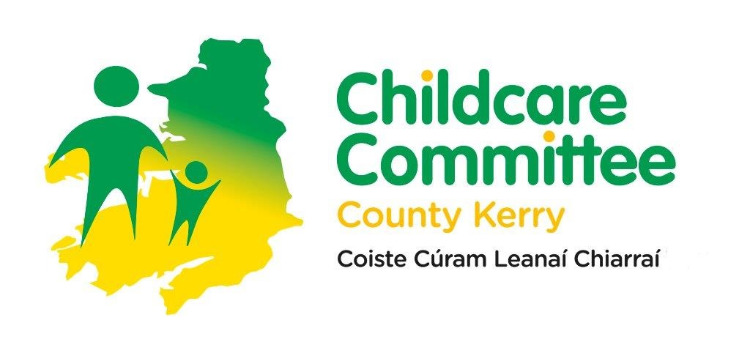
We invite you to follow our Instagram page here, visit our website here and like and follow our Facebook page for updates and relevant content.

Kind regards
Kerry County Childcare Committee

